- PROJECT SUMMARY

1.0 Introduction

In the rapidly evolving landscape of educational institutions, the need for efficient digital solutions has become paramount. This project focuses on the development of a Library Management System (LMS), a web-based application designed to modernize library operations within a college setting. The LMS incorporates user-friendly features such as admin and user login portals, book inventory management, real-time borrowing and returning functionalities, and integration with Firebase for secure data handling. By leveraging HTML, CSS, and JavaScript for the frontend, this system addresses common pain points in traditional libraries, including manual record-keeping and limited accessibility. The provided code snippet serves as the foundational interface, featuring intuitive login buttons and SVG icons to enhance user experience.

The business case for this LMS underscores its organizational necessity, particularly in institutions like Central Metropolitan College where resource management directly impacts student success and administrative efficiency. Manual processes often lead to errors, delays, and increased costs, such as lost books or overtime for staff. Implementing this digital system will streamline operations, reduce paperwork by automating transactions, and provide 24/7 access to library resources via any device. This aligns with broader goals of digital transformation, fostering a more productive environment that supports remote learning and quick resource allocation. Ultimately, the LMS promises to cut operational costs by minimizing physical handling and errors, while boosting user satisfaction through seamless interactions.

The Project Charter formalizes the project's framework: Project Name - Library Management System; Description - A secure online portal for library administration and user services using web technologies and Firebase; Deliverables - Functional login system, database integration, user dashboards, and deployment documentation; Benefits - Enhanced efficiency, cost savings, and improved accessibility; Risks - Potential integration issues with Firebase or security vulnerabilities; Budget - $5,000 allocated for tools, hosting, and testing. This charter ensures all stakeholders are aligned from the outset.

This project aligns with strategic organizational goals by advancing technological infrastructure to support educational excellence and operational agility. Key stakeholder groups include librarians, interested in robust inventory tools, and students, focused on easy access to resources. The system will reduce costs by automating routine tasks and improve efficiency through real-time updates. Spanning 67 days from September 6, 2025, to November 12, 2025, the project integrates artifacts via GitHub at https://github.com/user/library-management-system, hosting README.md, screenshots, and code for transparency and collaboration.
1.0.1 The Project Charter outlines the key elements as follows:
- Project Name: Library Management System
- Description: A web-based application for managing library books, user accounts, and administrative tasks using HTML, JavaScript, and Firebase.
- Deliverables: Functional login portal, book database integration, user dashboard for borrowing/returning books, admin panel for inventory management, and deployment to a hosting platform.
- Benefits: Improved efficiency in book tracking, reduced manual errors, enhanced user experience through online access, and cost savings on physical record-keeping.
- Risks: Potential data security vulnerabilities from Firebase integration, technical issues with cross-browser compatibility, and delays due to team coordination.
- Budget: Estimated at $5,000, covering development tools, hosting fees, and testing resources.
The project aligns with strategic organizational goals by supporting digital education initiatives, promoting resource efficiency, and fostering a tech-savvy environment that enhances learning and administrative productivity in line with the college's mission to modernize operations.
Two stakeholder groups are librarians (as admins), whose primary interests include easy inventory management and report generation, and students/patrons (as users), who prioritize quick book searches and seamless borrowing processes. The project will reduce operational costs by automating manual tracking, minimizing paper usage, and decreasing staff time spent on routine tasks like check-ins/check-outs, while improving efficiency through real-time updates that prevent overborrowing or lost items.
The project duration is 67 days total, with a start date of September 6, 2025, and an end date of November 12, 2025. The GitHub repository URL is https://github.com/user/library-management-system. It integrates project artifacts by hosting the README.md with an overview and charter summary, links to Smartsheet artifacts, screenshots of WBS and Gantt charts, code snippets from the HTML portal (including Firebase initialization), and system architecture diagrams showing frontend-backend flow.
1.1 DETAIL ABOUT SOFTWARE USED
Smartsheet is described as a cloud-based collaborative project management platform that enables teams to plan, track, and automate workflows in real-time. It functions like a dynamic spreadsheet with advanced features for task assignment, Gantt charts, and integrations, making it ideal for IT projects by allowing seamless sharing and updates without requiring extensive technical expertise.
Comparing Smartsheet vs. Microsoft Project: One advantage of Smartsheet is its intuitive, user-friendly interface that supports no-code automation and real-time collaboration, making it accessible for non-technical users. One advantage of Microsoft Project is its robust scheduling capabilities for complex, enterprise-level projects with detailed resource allocation and baseline tracking.
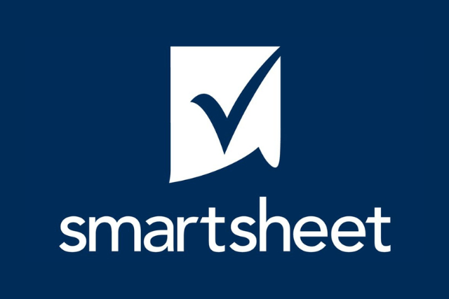
Figure 1: Smartsheet main interface
Smartsheet is accessible on three platforms: web browsers (via desktop or laptop), iOS mobile app, and Android mobile app The key difference between Editor-can share and Editor-cannot share is that Editor-can share allows the user to invite others and share the sheet or workspace, while Editor-cannot share restricts this ability, preventing the user from adding new collaborators but still permitting edits to content.
Smartsheet supports no-code automation for non-technical users through its built-in workflow builder, where users can create automated actions like alerts, approvals, updates, and data integrations using drag-and-drop interfaces, without writing any code, enabling efficient process streamlining across teams.

1.1.1 DETAIL ABOUT PROJECT AND OUTCOME
This section develops the core project artifacts for the Library Management System, including team structure, milestones, WBS, Gantt chart, software plan, and scope statement, all created using Smartsheet for collaborative tracking and integrated into GitHub for version control.

1.2 Project objective
To design, develop, and deploy a fully functional web-based Library Management System (LMS) within 67 days that digitizes library operations, improves resource accessibility for students and staff, and reduces administrative workload through automation and real-time data management.

1.2.1 Specific Objectives
- To implement a secure dual-access portal (Admin and User login) using HTML, CSS, JavaScript, and Firebase Authentication and Firestore as the backend database.
- To enable core library functions including book cataloging, search, borrowing, returning, reservation, and fine tracking with real-time updates.
- To apply PMBOK Initiating and Planning processes by creating a comprehensive Project Charter, Scope Statement, WBS, and 67-day Gantt Chart using Smartsheet as the primary collaborative tool.

1.2.2 Measurable Success Criteria
- System successfully deployed and accessible online
- All Smartsheet artifacts (WBS, Gantt, Milestones) publicly viewable
- GitHub repository active with README, code, and screenshots
- Zero critical bugs during final testing
- Positive feedback from simulated stakeholders (lecturer/admin/users)

1.3 Project Team
Role | Responsibilities | Assigned Group Member
Project Manager | Oversee planning, coordinate tasks, manage risks, and ensure timely delivery. | Eva israt
Developer | Build the frontend (HTML/CSS/JS) and integrate backend (Firebase for auth and DB). | Eva israt
Tester | Conduct unit/integration testing, identify bugs, and verify functionality. | Naimul islam
Designer | Design UI/UX elements, create wireframes, and ensure accessibility. | Naimul islam

